Ellen Hirst  LB North East and Yorkshire  Newcastle upon Tyne  NE98 1ZZ |   Date: 23 June 2025  Our Ref:

Notice letter for Great Red Storage REIT to become a UK REIT
Dear Ellen,
We are writing on behalf of Great Red Storage REIT to give notice under s. 524 Corporation Tax Act 2010 that it wishes to become a UK REIT from 15 August 2025.
Great Red Storage REIT will be a group REIT.
We intend for its first REIT accounting period to begin on 15 August 2025 and end on 14 August 2029. We expect that the accounts for Great Red Storage REIT will be prepared on [practitioner input date].
We can confirm that Great Red Storage REIT meets the following conditions necessary for becoming a REIT:
- It satisfies Company Condition A because it is a UK company. It is incorporated in England (Incorporation Registration Number 3625198) and is not tax resident anywhere outside the UK.
- It satisfies Company Condition B because it is not an open-ended investment company under s. 236 Financial Services and Markets Act 2000.
- It satisfies Company Condition C because 82.62% of its ordinary shares are held by institutional investors, which is in excess of the statutory 70% required. Details of how Great Red Storage REIT meets this requirement are included in Appendix 1C.
- It meets Company Condition D, since it is not a close company. Great Red Storage REIT is not a close company because it passes both the control and assets tests. More details are provided in Appendix 1D.
- It satisfies Company Condition E because it has only one class of ordinary shares, and restricted preference shares that carry no voting rights and a right to dividends that is permitted.
- It satisfies Company Condition F because none of its debts have any statutorily prohibited features. That is, none of the loans where Great Red Storage REIT is the debtor contain terms where:
a) the loan interest depends on the results of its business or the value of its assets;
b) the loan interest exceeds a reasonable commercial return on the principal lent;
c) the total repayment exceeds the principal lent or reasonable market rates.
Going forwards, Great Red Storage REIT will ensure any additional debt finance it secures is compatible with the requirements of Company Condition F.
We look forwards to hearing from you in due course on Great Red Storage REIT's approval to become a REIT. If there is any further way that we can assist you in your determination, we would be pleased to help.
Yours Sincerely,
Smithers Solicitors

Appendix 1C: Institutional investors
Great Red Storage REIT meets Company Condition C because 82.62% of its ordinary share capital is held by institutional investors, which is more than the statutory 70% threshold.
The table below records who the institutional investors in Great Red Storage REIT are, why we say they fall inside one of the statutory categories of institutional investors, and their total shareholding in Great Red Storage REIT.
Two of these investors are limited partnerships which need genuine diversity of ownership to be classed as institutional. We have confirmed that they have this diversity, and would be happy to share our basis for those conclusions if this would assist with your verification that Great Red Storage REIT meets Company Condition C.
Investor name | Institutional investor category | Total (%)
AfterCare LLP | AfterCare LLP is a limited partnership which is a collective investment scheme.  [Enter notes as appropriate] | 5.0
Hospice on the Shore | Hospice on the Shore is a charity.  [Its charities number is 1145022] | 6.0
Herbert Brothers LLP | Herbert Brothers LLP is a limited partnership which is a collective investment scheme.  [Enter notes as appropriate] | 8.0
Mercutor Insurance | Mercutor Insurance has a long-term insurance business.  [Mercutor has a letter from the PRA granting it permission to act in the long-term insurance business, dated 06/06/2011 (their reference no JL99320611] | 10.0
Heartworks | Heartworks is a charity.  [Heartworks' charity number is 0345567.] | 7.0
GIC | GIC has sovereign immunity from direct UK taxes.  [Enter notes as appropriate] | 5.08
Carter Players | Carter Players is a charity.  [Charity number 4684277.] | 7.6
Switchers | Switchers is a charity.  [Charity number 5798461.] | 6.6
Farron's End | Farron's End is a charity.  [Charity number 1057821.] | 5.6
St. Clare's | St. Clare's is a charity.  [Charity number 1330891.] | 3.48
Westmind | Westmind is a charity.  [Charity number 2311053.] | 3.0
Garren's Men | Garren's Men is a charity.  [Charity number 9819213.] | 5.6
Herringside Carers | Herringside Carers is a charity.  [Charity number 4566281.] | 2.16
The LD Foundation | The LD Foundation is a charity.  [Charity number 7645438.] | 2.72
Barron HomeHelp | Barron HomeHelp is a charity.  [Charity number 1346189.] | 2.38
Williams Hearts | Williams Hearts is a charity.  [Charity number 1330447.] | 1.6
King Unit Trust | King Unit Trust is the trustee/manager [delete as appropriate] of an FCA authorised unit trust.  [The FCA confirmed by a letter dated 03/04/2015 that the Fund was approved as a unit trust (their reference no DR34-04/15)] | 0.8
Total |  | 82.62

Institutional investor diagrams
These diagrams represent each institutional investor's total ownership of Great Red Storage REIT's ordinary share capital.
AfterCare LLP
AfterCare LLP directly owns 5.00% of Great Red Storage REIT.
Hospice on the Shore
Hospice on the Shore directly owns 6.00% of Great Red Storage REIT.
Herbert Brothers LLP
Herbert Brothers LLP directly owns 8.00% of Great Red Storage REIT.
Mercutor Insurance
Mercutor Insurance directly owns 10.00% of Great Red Storage REIT.
Heartworks
Heartworks directly owns 7.00% of Great Red Storage REIT.
GIC
GIC holds this interest in Great Red Storage REIT through the following paths.
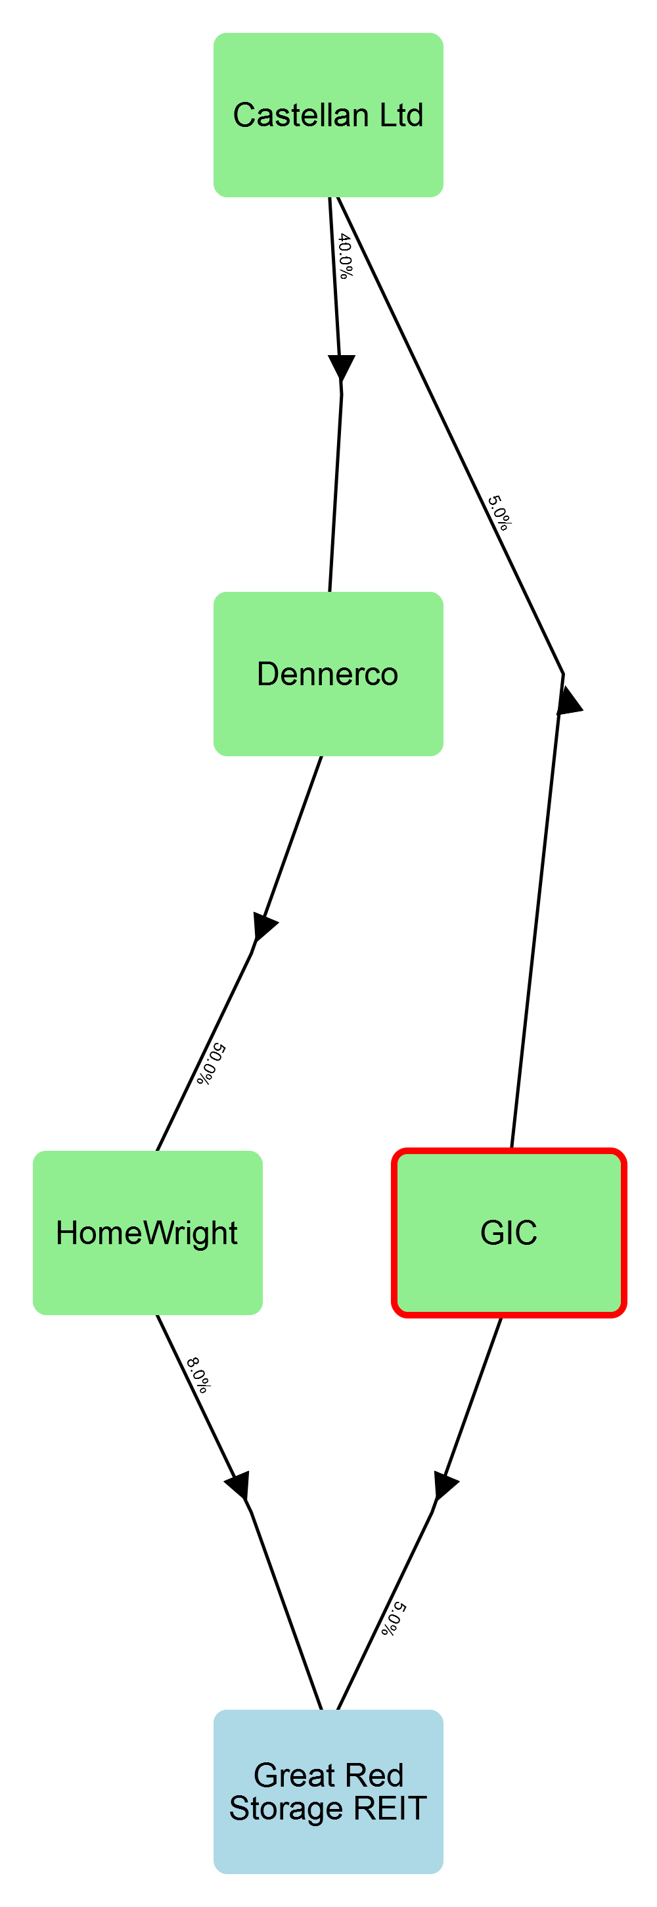
Intermediaries | Path %
None (direct ownership) | 5.0
Castellan Ltd, Dennerco, and HomeWright | 0.08

Carter Players
Carter Players holds this interest in Great Red Storage REIT through the following paths.
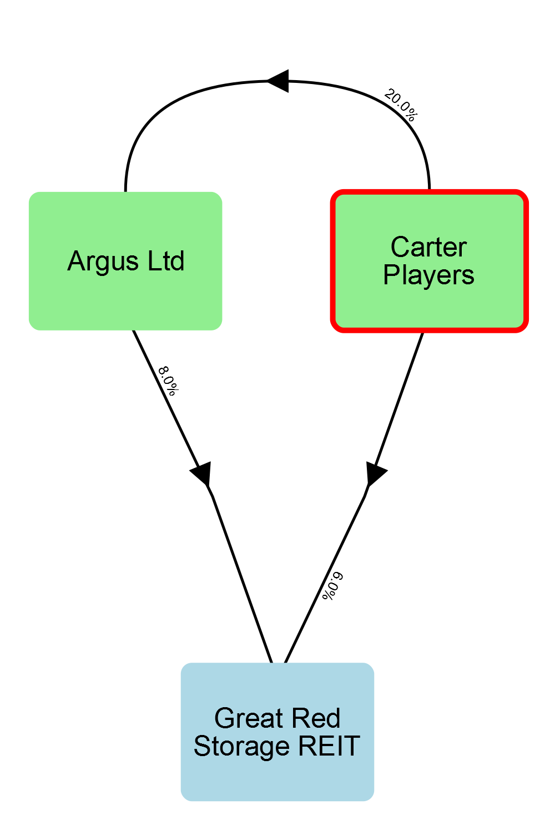
Intermediaries | Path %
None (direct ownership) | 6.0
Argus Ltd | 1.6

Switchers
Switchers holds this interest in Great Red Storage REIT through the following paths.
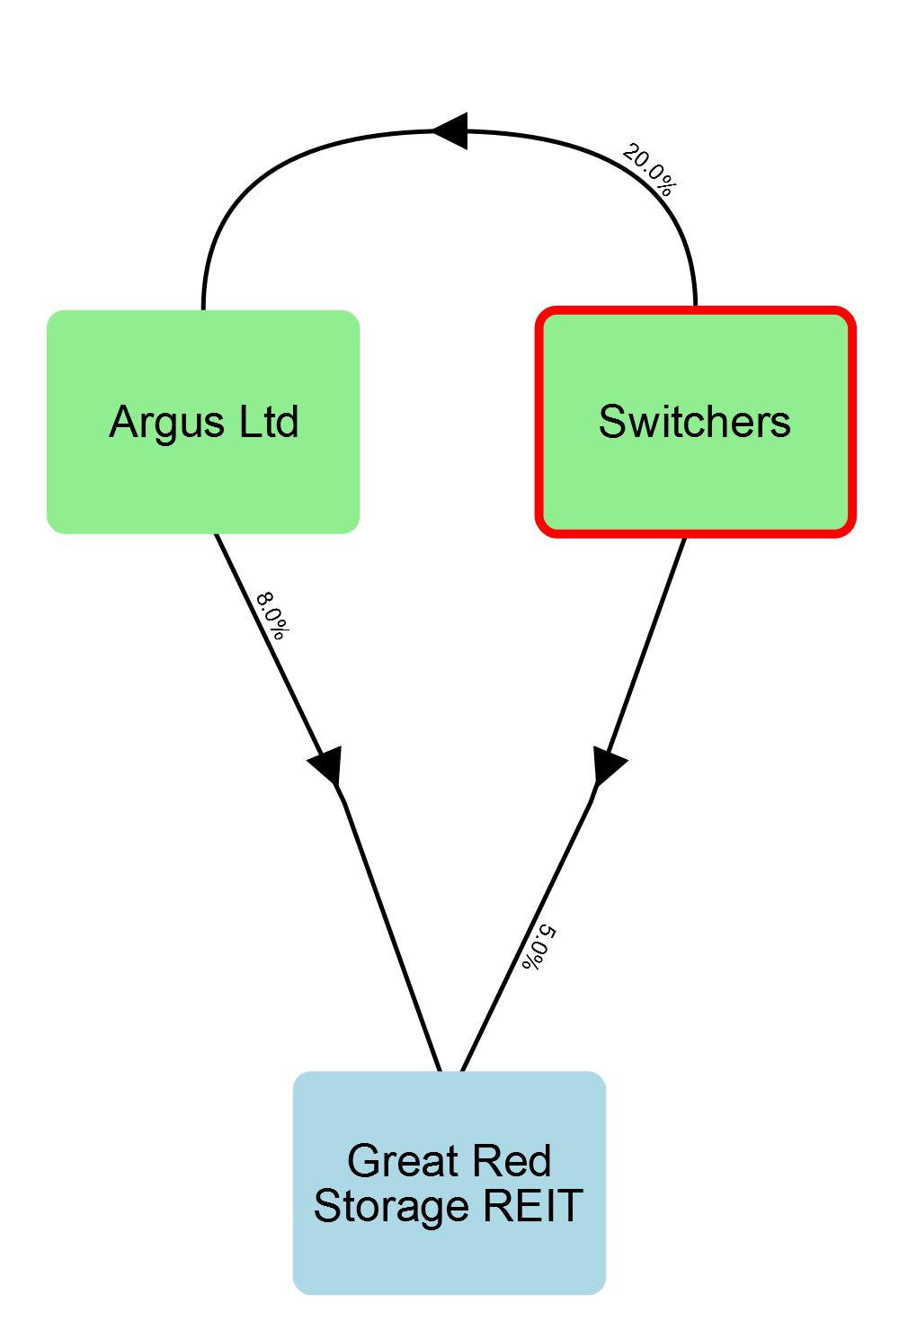
Intermediaries | Path %
None (direct ownership) | 5.0
Argus Ltd | 1.6

Farron's End
Farron's End holds this interest in Great Red Storage REIT through the following paths.
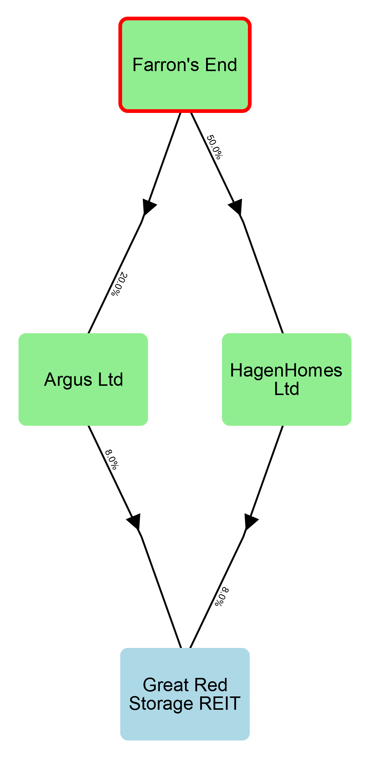
Intermediaries | Path %
HagenHomes Ltd | 4.0
Argus Ltd | 1.6

St. Clare's
St. Clare's holds this interest in Great Red Storage REIT through the following paths.
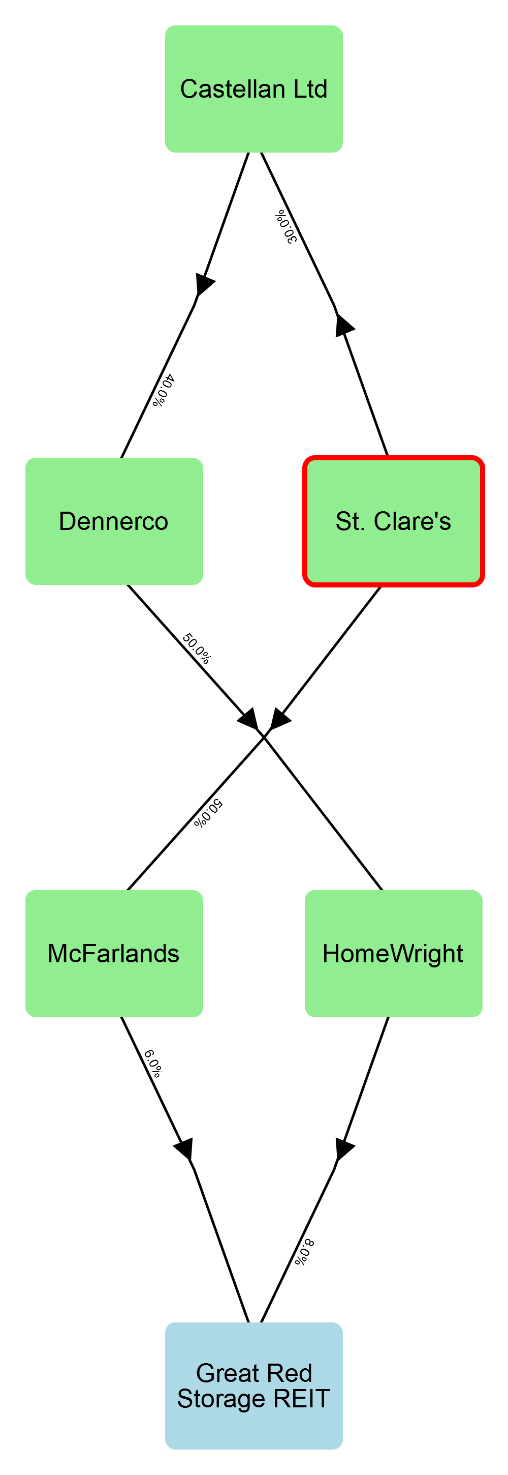
Intermediaries | Path %
McFarlands | 3.0
Castellan Ltd, Dennerco, and HomeWright | 0.48

Westmind
Westmind holds this interest in Great Red Storage REIT through the following path.
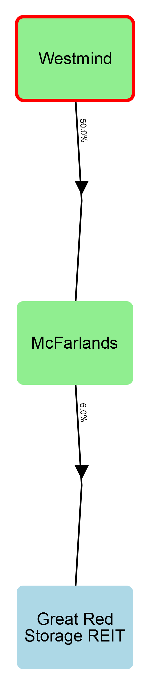
Intermediaries | Path %
McFarlands | 3.0

Garren's Men
Garren's Men holds this interest in Great Red Storage REIT through the following paths.
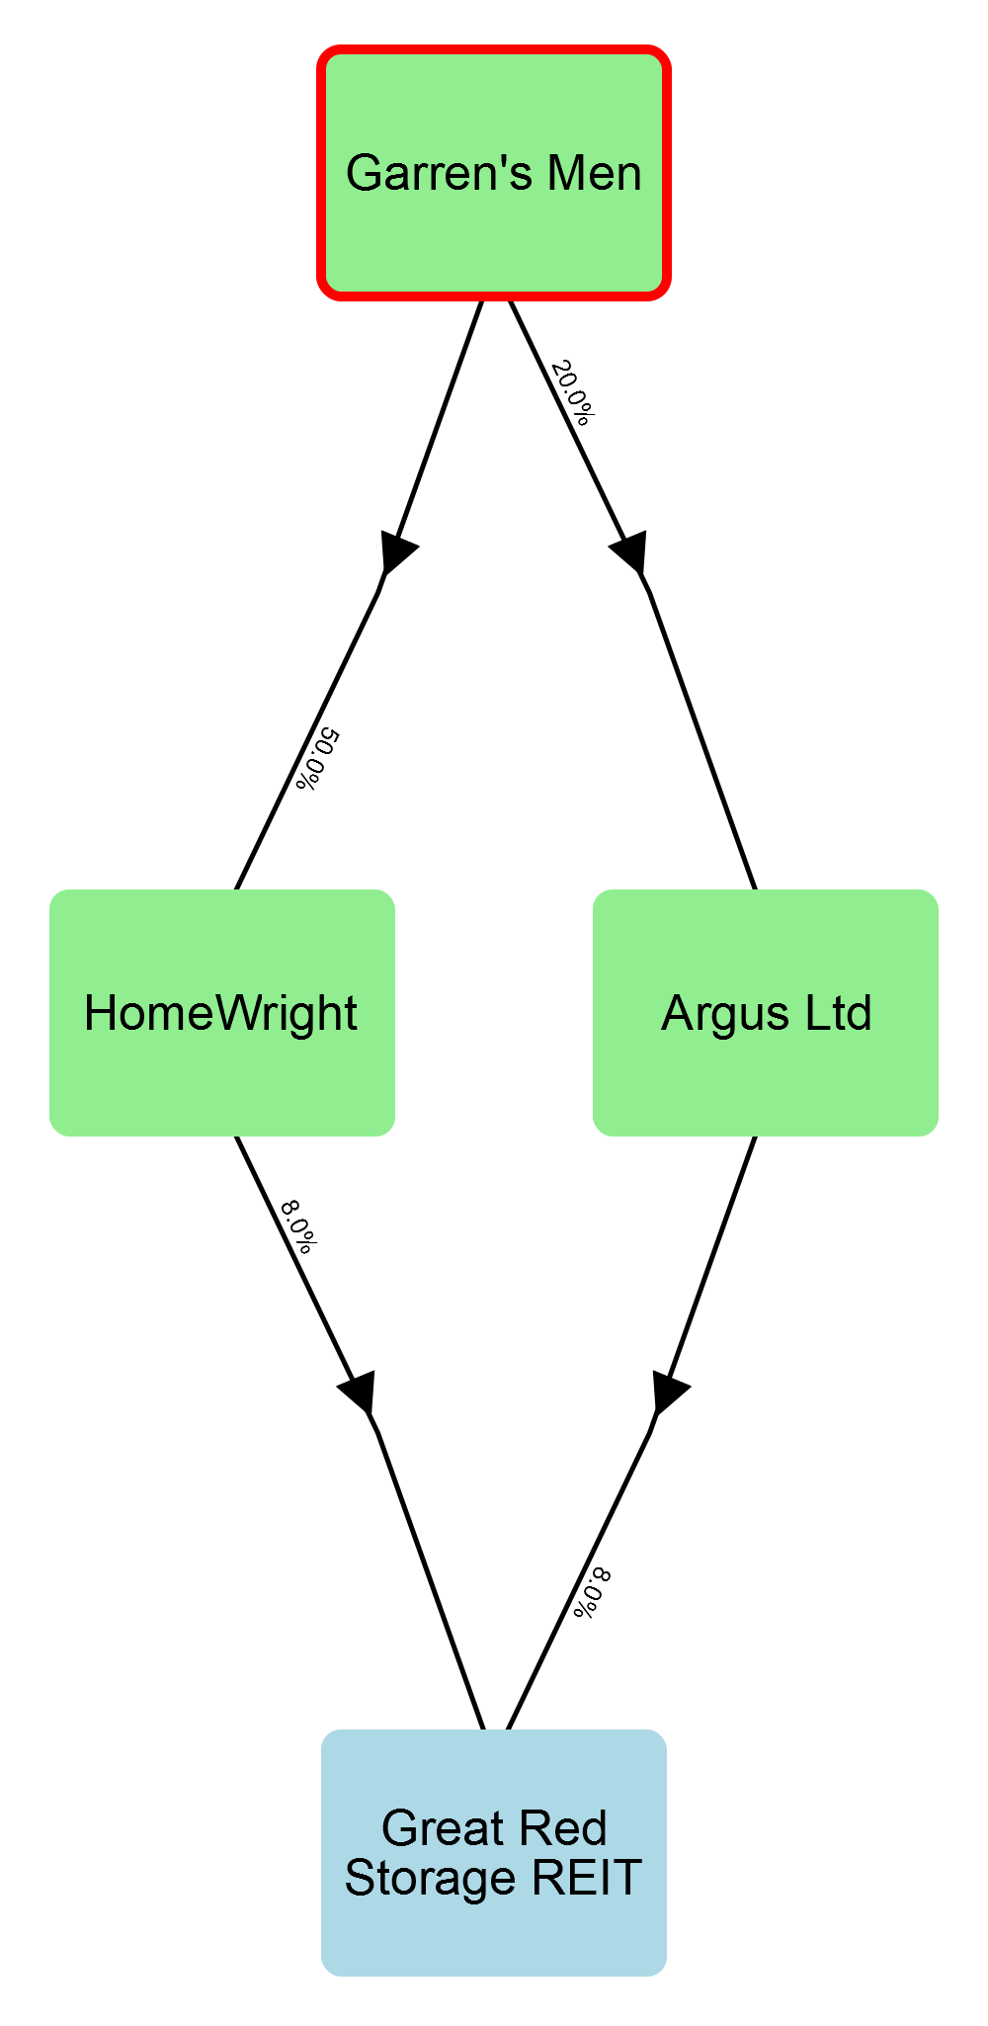
Intermediaries | Path %
HomeWright | 4.0
Argus Ltd | 1.6

Herringside Carers
Herringside Carers holds this interest in Great Red Storage REIT through the following paths.
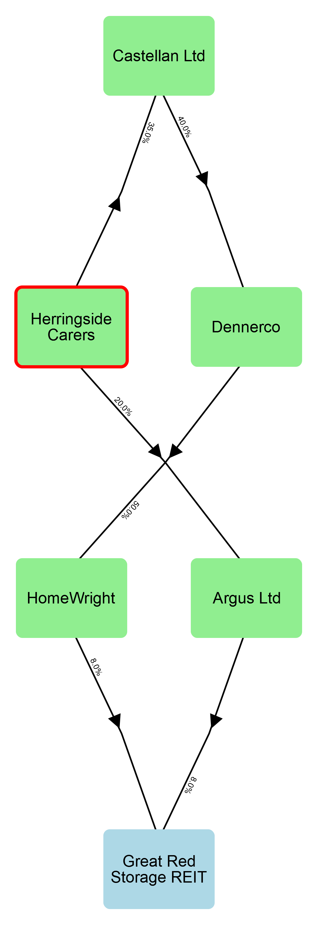
Intermediaries | Path %
Argus Ltd | 1.6
Castellan Ltd, Dennerco, and HomeWright | 0.56

The LD Foundation
The LD Foundation holds this interest in Great Red Storage REIT through the following paths.
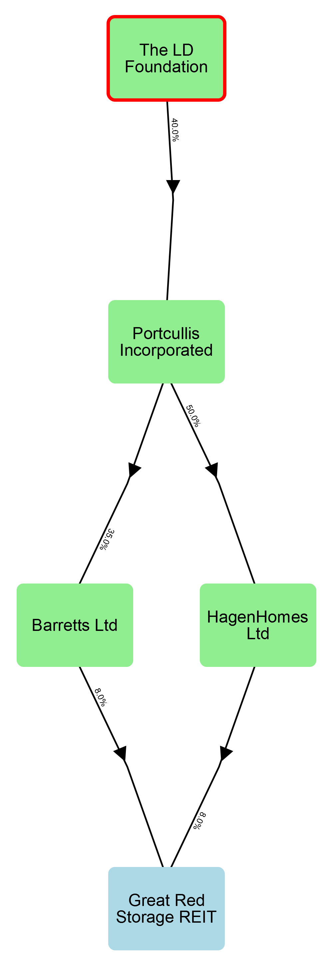
Intermediaries | Path %
Portcullis Incorporated and HagenHomes Ltd | 1.6
Portcullis Incorporated and Barretts Ltd | 1.12

Barron HomeHelp
Barron HomeHelp holds this interest in Great Red Storage REIT through the following paths.
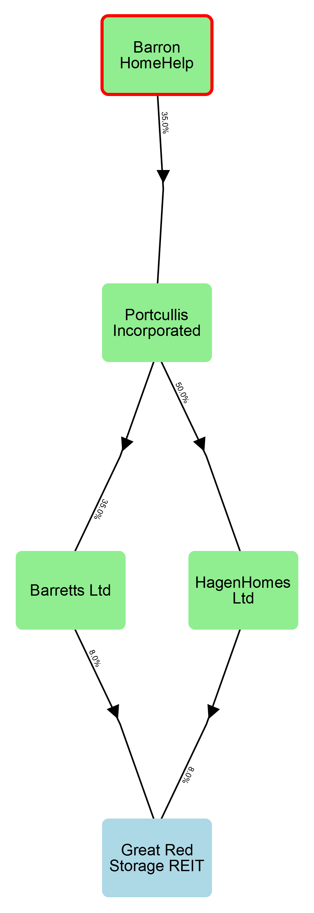
Intermediaries | Path %
Portcullis Incorporated and HagenHomes Ltd | 1.4
Portcullis Incorporated and Barretts Ltd | 0.98

Williams Hearts
Williams Hearts holds this interest in Great Red Storage REIT through the following path.
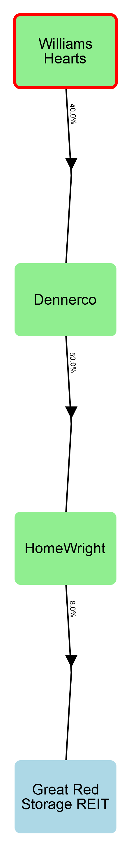
Intermediaries | Path %
Dennerco and HomeWright | 1.6

King Unit Trust
King Unit Trust holds this interest in Great Red Storage REIT through the following path.
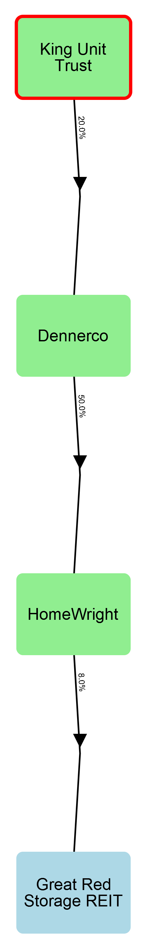
Intermediaries | Path %
Dennerco and HomeWright | 0.8

Appendix 1D: Closed company analysis

Involved parties
The table below records all parties involved with Great Red Storage REIT, which close company tests (if any) they are relevant to, and whether they are also a director or lender. It also identifies who their statutory associates are.
Name (ID) | Participator in tests | Director in tests | Lender | Associates
AfterCare LLP (2) | - | - | -
Argus Ltd (10) | Control | - | -
Barretts Ltd (5) | Control | - | -
Barron HomeHelp (37) | Assets | - | -
Carter Players (35) | Both | - | -
Caspar Renson (19) | Assets | - | -
Castellan Ltd (18) | - | - | -
Dennerco (20) | - | - | -
Farron's End (34) | Assets | - | -
GIC (17) | Both | - | -
Garren's Men (33) | Assets | - | -
HagenHomes Ltd (6) | Control | - | -
Heartworks (11) | Both | - | -
Herbert Brothers LLP (4) | - | - | -
Herringside Carers (32) | Assets | - | -
HomeWright (8) | Control | - | -
Hospice on the Shore (3) | Both | - | -
King Unit Trust (21) | Assets | - | -
Mandy Kingley (13) | Both | Control | - | Tom Watkins (child)
McFarlands (7) | Control | - | -
Mercutor Insurance (9) | Control | - | -
Obduras Partners (14) | - | - | -
Portcullis Incorporated (16) | - | - | -
Solomon LPP (22) | Assets | - | -
St. Clare's (31) | Assets | - | -
Switchers (36) | Both | - | -
The LD Foundation (38) | Assets | - | -
Tom Watkins (12) | Both | Control | - | Mandy Kingley (parent)
Van Tork Ltd (15) | - | - | -
Westmind (30) | Assets | - | -
Williams Hearts (39) | Assets | - | -

Appendix 1D: Control test in detail
In total, there are sixteen statutory 'participators' in Great Red Storage REIT for the purposes of the control test. After performing the statutory process of attributing rights, 44.00% of Great Red Storage REIT's shares are held by a group of five of these participators, which is less than the 50% threshold for that group to be in control. There are two directors of Great Red Storage REIT who are also participators for the purposes of this control test. These directors collectively hold 10.00% of the shares, which is less than the 50% control threshold. The attributions made can be reviewed in the section below titled 'Attribution of rights'.

Participators
The table below records who the statutory participators in Great Red Storage REIT are, and explains why they are participators for the purposes of the control test.
Participator | Reason for participator status
Argus Ltd | Direct ownership
Barclays | Lender
Barretts Ltd | Direct ownership
Carter Players | Direct ownership
GIC | Direct ownership
HSBC | Lender
HagenHomes Ltd | Direct ownership
Heartworks | Direct ownership
HomeWright | Direct ownership
Hospice on the Shore | Direct ownership
Mandy Kingley | Direct ownership
McFarlands | Direct ownership
Mercutor Insurance | Direct ownership
Switchers | Direct ownership
The Ursine Group | Lender
Tom Watkins | Direct ownership

Directors
There are no statutory participators in Great Red Storage REIT who are also directors for the purposes of the control test.

Attribution of rights
Four statutory measures of control were considered to determine if Great Red Storage REIT satisfies the control test: share capital, voting rights, rights to income, and rights to assets on winding up.
The statutory process of attributing rights was performed. This process requires rights be attributed between associates with a view to achieving the highest concentration of rights within the smallest group of participators.
The highest concentration of rights was achieved in relation to share capital. The table below records how the share capital in Great Red Storage REIT was initially distributed among its statutory participators, and how the share capital was attributed to maximise concentration.
Participator | Initial (%) | Attributions made | Final (%)
Argus Ltd | 8.00% | No attributions | 8.00%
Barclays | 0.00% | No attributions | 0.00%
Barretts Ltd | 8.00% | No attributions | 8.00%
Carter Players | 6.00% | No attributions | 6.00%
GIC | 5.00% | No attributions | 5.00%
HSBC | 0.00% | No attributions | 0.00%
HagenHomes Ltd | 8.00% | No attributions | 8.00%
Heartworks | 7.00% | No attributions | 7.00%
HomeWright | 8.00% | No attributions | 8.00%
Hospice on the Shore | 6.00% | No attributions | 6.00%
Mandy Kingley* | 5.00% | 5.00% transferred to Tom Watkins | 0.00%
McFarlands | 6.00% | No attributions | 6.00%
Mercutor Insurance | 10.00% | No attributions | 10.00%
Switchers | 5.00% | No attributions | 5.00%
The Ursine Group | 0.00% | No attributions | 0.00%
Tom Watkins* | 5.00% | 5.00% received from Mandy Kingley | 10.00%
Therefore the 5 participators with the greatest proportion of share capital control 44.0%.
The total proportion of share capital controlled by directors who are also participators (*) is 10.0%.

Appendix 1D: Assets test in detail
In total, there are eighteen statutory participators in Great Red Storage REIT for the purposes of the assets test. After statutory rights attributions, 37.20% of its assets are held by a group of five of these participators, which is below the 50% threshold for that group to be in control. If the rights of loan creditors are disregarded, 25.11% of Great Red Storage REIT's assets are held by these participators. This is below the 50% threshold. There are no directors of Great Red Storage REIT who are also participators for the purposes of this assets test. The attributions made can be reviewed in the section below titled 'Attribution of rights'.

Participators
The table below records who the statutory participators in Great Red Storage REIT are, and explains why they are participators for the purposes of the assets test.
Participator | Reason for participator status
Barclays | Lender
Barron HomeHelp | Indirect entitlement via Portcullis Incorporated and HagenHomes Ltd
Carter Players | Indirect entitlement via Argus Ltd
Caspar Renson | Indirect entitlement via Castellan Ltd, Dennerco, and HomeWright
Farron's End | Indirect entitlement via Argus Ltd
GIC | Indirect entitlement via Castellan Ltd, Dennerco, and HomeWright
Garren's Men | Indirect entitlement via Argus Ltd
HSBC | Lender
Heartworks | Direct entitlement
Herringside Carers | Indirect entitlement via Castellan Ltd, Dennerco, and HomeWright
Hospice on the Shore | Direct entitlement
King Unit Trust | Indirect entitlement via Dennerco and HomeWright
Mandy Kingley | Direct entitlement
Solomon LPP | Indirect entitlement via Obduras Partners and Barretts Ltd
St. Clare's | Indirect entitlement via Castellan Ltd, Dennerco, and HomeWright
Switchers | Indirect entitlement via Argus Ltd
The LD Foundation | Indirect entitlement via Portcullis Incorporated and HagenHomes Ltd
The Ursine Group | Lender
Tom Watkins | Direct entitlement
Westmind | Indirect entitlement via McFarlands
Williams Hearts | Indirect entitlement via Dennerco and HomeWright

Directors
There are no statutory participators in Great Red Storage REIT who are also directors for the purposes of the assets test.

Attribution of rights
The table below records how the winding-up rights in Great Red Storage REIT were initially distributed among its statutory participators, and how the winding-up rights were attributed to maximise concentration for the purposes of the assets test.
Participator | Initial (%) | Attributions made | Final (%)
Barron HomeHelp | 2.38% | No attributions | 2.38%
Carter Players | 7.60% | No attributions | 7.60%
Caspar Renson | 0.48% | No attributions | 0.48%
Farron's End | 5.60% | No attributions | 5.60%
GIC | 5.08% | No attributions | 5.08%
Garren's Men | 5.60% | No attributions | 5.60%
Heartworks | 7.00% | No attributions | 7.00%
Herringside Carers | 2.16% | No attributions | 2.16%
Hospice on the Shore | 6.00% | No attributions | 6.00%
King Unit Trust | 0.80% | No attributions | 0.80%
Mandy Kingley | 5.00% | 5.00% transferred to Tom Watkins | 0.00%
Solomon LPP | 2.80% | No attributions | 2.80%
St. Clare's | 3.48% | No attributions | 3.48%
Switchers | 6.60% | No attributions | 6.60%
The LD Foundation | 2.72% | No attributions | 2.72%
Tom Watkins | 5.00% | 5.00% received from Mandy Kingley | 10.00%
Westmind | 3.00% | No attributions | 3.00%
Williams Hearts | 1.60% | No attributions | 1.60%
Therefore the 5 participators with the greatest proportion of winding-up rights control 37.2% (25.11% if the rights of loan creditors are disregarded).
The total proportion of winding-up rights controlled by directors who are also participators (*) is 0.0% (0.0% if the rights of loan creditors are disregarded).

UK Corporation Tax Act 2010, ss.528(1), 521(1); UK Corporation Tax Act 2009, s.14(1).
UK Corporation Tax Act 2010, s.528(2); UK Financial Services and Markets Act 2000, s.236.
UK Corporation Tax Act 2010, s.528(3)(b).
UK Corporation Tax Act 2010, ss.528(6)-(7), 160, 1115, 1119.
UK Corporation Tax Act 2010, ss.528(8)-(9).
UK Corporation Tax Act 2010 s. 528(3)(b).
UK Corporation Tax Act 2010, s.528(3)(b).
UK Corporation Tax Act 2010, s.528(4A)(c); UK Financial Services and Markets Act s.235.
UK Corporation Tax Act 2010, s.528(4A)(f).
UK Corporation Tax Act 2010, s.528(4A)(c); UK Financial Services and Markets Act s.235.
UK Corporation Tax Act 2010, s.528(4A)(e)(i); UK Financial Services and Markets Act (Regulated Activities) Order 2001, SI 2001/544 Pt II Sch 1.
UK Corporation Tax Act 2010, s.528(4A)(f).
UK Corporation Tax Act 2010, s.528(4A)(h).
UK Corporation Tax Act 2010, s.528(4A)(f).
UK Corporation Tax Act 2010, s.528(4A)(f).
UK Corporation Tax Act 2010, s.528(4A)(f).
UK Corporation Tax Act 2010, s.528(4A)(f).
UK Corporation Tax Act 2010, s.528(4A)(f).
UK Corporation Tax Act 2010, s.528(4A)(f).
UK Corporation Tax Act 2010, s.528(4A)(f).
UK Corporation Tax Act 2010, s.528(4A)(f).
UK Corporation Tax Act 2010, s.528(4A)(f).
UK Corporation Tax Act 2010, s.528(4A)(f).
UK Corporation Tax Act 2010, s.528(3)(b).
UK Corporation Tax Act 2010, s.452.
UK Corporation Tax Act 2010, s.453.
UK Corporation Tax Act 2010, s.448.
UK Corporation Tax Act 2010, s.454.
UK Corporation Tax Act 2010, s.454.
UK Corporation Tax Act 2010, s.454.
UK Corporation Tax Act 2010, s.454.
UK Corporation Tax Act 2010, s.454.

