Ellen Hirst  LB North East and Yorkshire  Newcastle upon Tyne  NE98 1ZZ |   Date: 23 June 2025  Our Ref:

Analysis of Kelsey REIT's eligibility to become a UK REIT
Dear Ellen
You asked us to provide an assessment of whether your proposed Kelsey REIT structure is eligible to become a UK REIT. We have completed the relevant analysis and, while it passes some of the applicable tests, unfortunately it fails Company Conditions C and D.
This report outlines which REIT tests Kelsey REIT passed and which it failed, and then provides our recommendations for how it could be restructured to ensure eligibility.
As a summary of Kelsey REIT's performance against the key REIT tests:
- It satisfies Company Condition A because it is a UK company. It is incorporated in England (Incorporation Registration Number 3625198) and is not tax resident anywhere outside the UK.
- It satisfies Company Condition B because it is not an open-ended investment company under s. 236 Financial Services and Markets Act 2000.
- It currently fails Company Condition C. This is because its ordinary shares are neither listed, nor admitted to trading, on a stock exchange recognised by HMRC, and only 60.14% of its shares are held by institutional investors, which does not meet the statutory 70% threshold. Details of why Kelsey REIT does not have enough institutional investors are set out in Appendix 1C.
- It currently fails Company Condition D since it is a close company, even when institutional investor participators are disregarded.
- It satisfies Company Condition E because it has only one class of ordinary shares, and restricted preference shares that carry no voting rights and a right to dividends that is permitted.
- It satisfies Company Condition F because none of its debts have any statutorily prohibited features. That is, none of the loans where Kelsey REIT is the debtor contain terms where:
a) the loan interest depends on the results of its business or the value of its assets;
b) the loan interest exceeds a reasonable commercial return on the principal lent;
c) the total repayment exceeds the principal lent or reasonable market rates.
Going forwards, Kelsey REIT will ensure any additional debt finance it secures is compatible with the requirements of Company Condition F.
[Practitioner recommendations for restructuring the REIT candidate]
Yours Sincerely,
Smithers Solicitors

Appendix 1C: Institutional investors
Only 60.14% of Kelsey REIT's ordinary share capital is held by institutional investors, which does not meet the statutory 70% threshold. Because Kelsey REIT's ordinary shares are also neither listed, nor admitted to trading on, a HMRC recognised share exchange, it fails Company Condition C and is not currently eligible to become a REIT.
The table below records who the institutional investors in Kelsey REIT are, why we have concluded they are inside a statutory category of institutional investor, and their total shareholding in Kelsey REIT. After these explanations, we outline our recommendations on how to make Kelsey REIT pass Company Condition C.
Investor name | Institutional investor category | Total (%)
AfterCare LLP | AfterCare LLP is a limited partnership which is a collective investment scheme.  [AfterCare is a limited liability partnership which serves as a collective investment scheme.] | 9.0
Hospice on the Shore | Hospice on the Shore is a charity.  [Its charities number is 1145022] | 7.0
Herbert Brothers LLP | Herbert Brothers LLP is a limited partnership which is a collective investment scheme.  [Enter notes as appropriate] | 8.0
Heartworks | Heartworks is a charity.  [Heartworks' charity number is 0345567.] | 7.0
GIC | GIC has sovereign immunity from direct UK taxes.  [Enter notes as appropriate] | 16.34
King Unit Trust | King Unit Trust is the trustee/manager [delete as appropriate] of an FCA authorised unit trust.  [The FCA confirmed by a letter dated 03/04/2015 that the Fund was approved as a unit trust (their reference no DR34-04/15] | 12.8
Total |  | 60.14

Institutional investor diagrams
These diagrams represent each institutional investor's total ownership of Kelsey REIT's ordinary share capital.
AfterCare LLP
AfterCare LLP directly owns 9.00% of Kelsey REIT.
Hospice on the Shore
Hospice on the Shore directly owns 7.00% of Kelsey REIT.
Herbert Brothers LLP
Herbert Brothers LLP directly owns 8.00% of Kelsey REIT.
Heartworks
Heartworks directly owns 7.00% of Kelsey REIT.
GIC
GIC holds this interest in Kelsey REIT through the following paths.
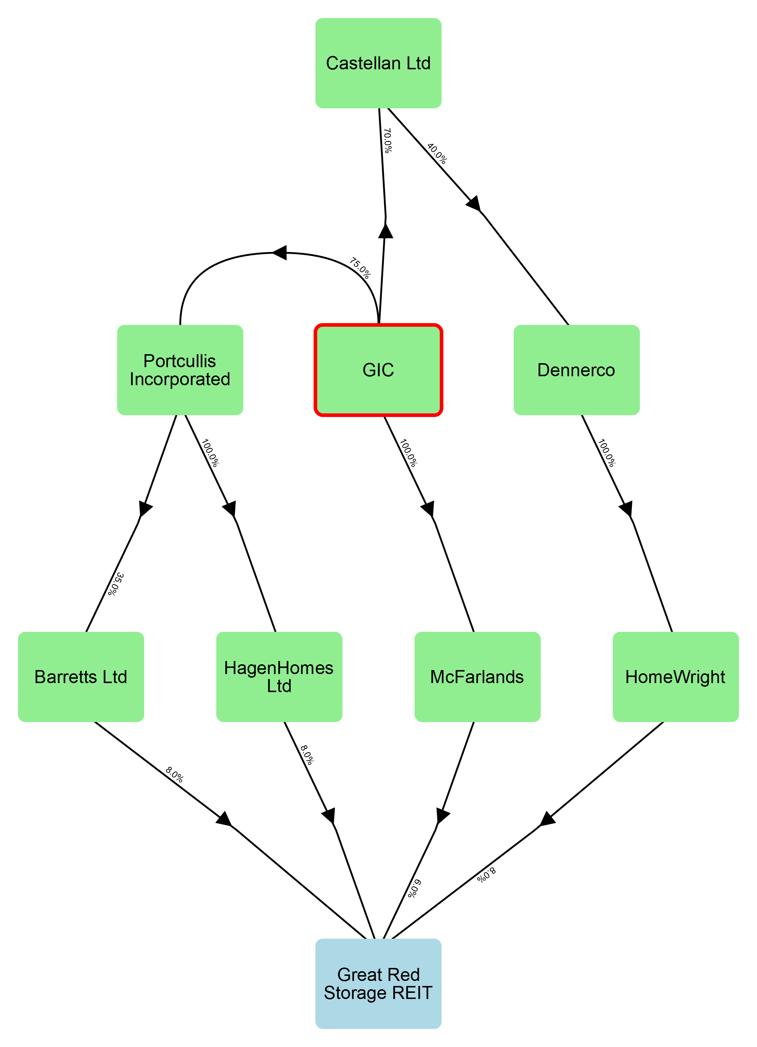
Intermediaries | Path %
Portcullis Incorporated and HagenHomes Ltd | 6.0
McFarlands | 6.0
Castellan Ltd, Dennerco, and HomeWright | 2.24
Portcullis Incorporated and Barretts Ltd | 2.1

King Unit Trust
King Unit Trust holds this interest in Kelsey REIT through the following paths.
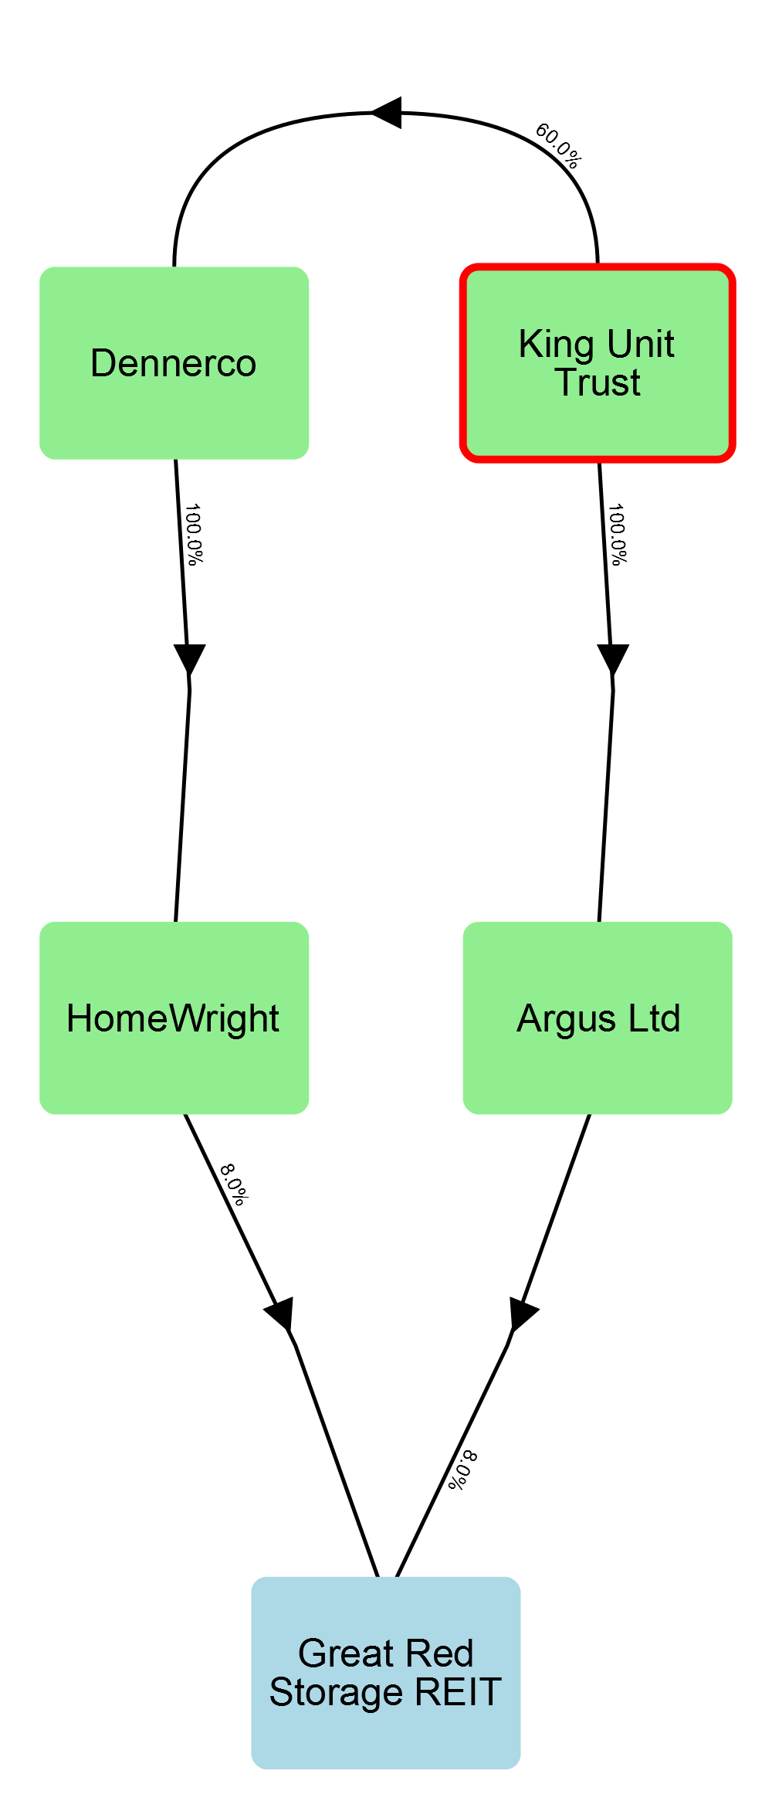
Intermediaries | Path %
Argus Ltd | 8.0
Dennerco and HomeWright | 4.8

Appendix 1D: Closed company analysis

Involved parties
The table below records all parties involved with Kelsey REIT, which close company tests (if any) they are relevant to, and whether they are also a director or lender. It also identifies who their statutory associates are.
Name (ID) | Participator in tests | Director in tests | Lender | Associates
AfterCare LLP (2) | - | - | -
Argus Ltd (10) | Control | - | -
Barretts Ltd (5) | Control | - | -
Caspar Renson (19) | Assets | - | -
Castellan Ltd (18) | - | - | -
Dennerco (20) | - | - | -
GIC (17) | Assets | - | -
HagenHomes Ltd (6) | Control | - | -
Heartworks (11) | Both | - | -
Herbert Brothers LLP (4) | - | - | -
HomeWright (8) | Control | - | -
Hospice on the Shore (3) | Both | - | -
King Unit Trust (21) | Assets | - | -
Mandy Kingley (13) | Both | Control | - | Tom Watkins (child)
McFarlands (7) | Control | - | -
Obduras Partners (14) | - | - | -
Portcullis Incorporated (16) | - | - | -
Solomon LPP (22) | Assets | - | -
Tom Watkins (12) | Both | Control | - | Mandy Kingley (parent)
Van Tork Ltd (15) | - | - | -

Appendix 1D: Control test in detail
In total, there are twelve statutory 'participators' in Kelsey REIT for the purposes of the control test. After performing the statutory process of attributing rights, 55.00% of Kelsey REIT's shares are held by a group of five of these participators, which is more than the 50% threshold for that group to be in control. There are two directors of Kelsey REIT who are also participators for the purposes of this control test. These directors collectively hold 23.00% of the shares, which is less than the 50% control threshold. The attributions made can be reviewed in the section below titled 'Attribution of rights'.

Participators
The table below records who the statutory participators in Kelsey REIT are, and explains why they are participators for the purposes of the control test.
Participator | Reason for participator status
Argus Ltd | Direct ownership
Barclays | Lender
Barretts Ltd | Direct ownership
HSBC | Lender
HagenHomes Ltd | Direct ownership
Heartworks | Direct ownership
HomeWright | Direct ownership
Hospice on the Shore | Direct ownership
Mandy Kingley | Direct ownership
McFarlands | Direct ownership
The Ursine Group | Lender
Tom Watkins | Direct ownership

Directors
There are no statutory participators in Kelsey REIT who are also directors for the purposes of the control test.

Attribution of rights
Four statutory measures of control were considered to determine if Kelsey REIT satisfies the control test: share capital, voting rights, rights to income, and rights to assets on winding up.
The statutory process of attributing rights was performed. This process requires rights be attributed between associates with a view to achieving the highest concentration of rights within the smallest group of participators.
The highest concentration of rights was achieved in relation to share capital. The table below records how the share capital in Kelsey REIT was initially distributed among its statutory participators, and how the share capital was attributed to maximise concentration.
Participator | Initial (%) | Attributions made | Final (%)
Argus Ltd | 8.00% | No attributions | 8.00%
Barclays | 0.00% | No attributions | 0.00%
Barretts Ltd | 8.00% | No attributions | 8.00%
HSBC | 0.00% | No attributions | 0.00%
HagenHomes Ltd | 8.00% | No attributions | 8.00%
Heartworks | 7.00% | No attributions | 7.00%
HomeWright | 8.00% | No attributions | 8.00%
Hospice on the Shore | 7.00% | No attributions | 7.00%
Mandy Kingley* | 6.00% | 6.00% transferred to Tom Watkins | 0.00%
McFarlands | 6.00% | No attributions | 6.00%
The Ursine Group | 0.00% | No attributions | 0.00%
Tom Watkins* | 17.00% | 6.00% received from Mandy Kingley | 23.00%
Therefore the 5 participators with the greatest proportion of share capital control 55.0%.
The total proportion of share capital controlled by directors who are also participators (*) is 23.0%.

Appendix 1D: Control test with institutional investor exception
Although Kelsey REIT is a close company under the control test, it can still satisfy Company Condition D if it is only close because it has as a participator an 'Institutional Investor'. The analysis that follows in this section excludes the Institutional Investors who were identified as participators in the preceding section's control test analysis.
Disregarding institutional investors, there are ten statutory 'participators' in Kelsey REIT for the purposes of the control test. After performing the statutory process of attributing rights, 55.00% of Kelsey REIT's shares are held by a group of five of these participators, which is more than the 50% threshold for that group to be in control. There are two directors of Kelsey REIT who are also participators for the purposes of this control test. These directors collectively hold 23.00% of the shares, which is less than the 50% control threshold. The attributions made can be reviewed in the section below titled 'Attribution of rights'.

Participators
The table below records who the statutory participators in Kelsey REIT are, and explains why they are participators for the purposes of the control test.The following participators were excluded on the grounds of being institutional investors: Heartworks and Hospice on the Shore
Participator | Reason for participator status
Argus Ltd | Direct ownership
Barclays | Lender
Barretts Ltd | Direct ownership
HSBC | Lender
HagenHomes Ltd | Direct ownership
HomeWright | Direct ownership
Mandy Kingley | Direct ownership
McFarlands | Direct ownership
The Ursine Group | Lender
Tom Watkins | Direct ownership

Directors
There are no statutory participators in Kelsey REIT who are also directors for the purposes of the control test.

Attribution of rights
Four statutory measures of control were considered to determine if Kelsey REIT satisfies the control test: share capital, voting rights, rights to income, and rights to assets on winding up.
The statutory process of attributing rights was performed. This process requires rights be attributed between associates with a view to achieving the highest concentration of rights within the smallest group of participators.
The highest concentration of rights was achieved in relation to share capital. The table below records how the share capital in Kelsey REIT was initially distributed among its statutory participators, and how the share capital was attributed to maximise concentration.
Participator | Initial (%) | Attributions made | Final (%)
Argus Ltd | 8.00% | No attributions | 8.00%
Barclays | 0.00% | No attributions | 0.00%
Barretts Ltd | 8.00% | No attributions | 8.00%
HSBC | 0.00% | No attributions | 0.00%
HagenHomes Ltd | 8.00% | No attributions | 8.00%
HomeWright | 8.00% | No attributions | 8.00%
Mandy Kingley* | 6.00% | 6.00% transferred to Tom Watkins | 0.00%
McFarlands | 6.00% | No attributions | 6.00%
The Ursine Group | 0.00% | No attributions | 0.00%
Tom Watkins* | 17.00% | 6.00% received from Mandy Kingley | 23.00%
Therefore the 5 participators with the greatest proportion of share capital control 55.0%.
The total proportion of share capital controlled by directors who are also participators (*) is 23.0%.

Appendix 1D: Assets test in detail
In total, there are eight statutory participators in Kelsey REIT for the purposes of the assets test. After statutory rights attributions, 66.14% of its assets are held by a group of five of these participators, which is above the 50% threshold for that group to be in control. If the rights of loan creditors are disregarded, 44.64% of Kelsey REIT's assets are held by these participators. This is below the 50% threshold. There are no directors of Kelsey REIT who are also participators for the purposes of this assets test. The attributions made can be reviewed in the section below titled 'Attribution of rights'.

Participators
The table below records who the statutory participators in Kelsey REIT are, and explains why they are participators for the purposes of the assets test.
Participator | Reason for participator status
Barclays | Lender
Caspar Renson | Indirect entitlement via Castellan Ltd, Dennerco, and HomeWright
GIC | Indirect entitlement via Castellan Ltd, Dennerco, and HomeWright
HSBC | Lender
Heartworks | Direct entitlement
Hospice on the Shore | Direct entitlement
King Unit Trust | Indirect entitlement via Dennerco and HomeWright
Mandy Kingley | Direct entitlement
Solomon LPP | Indirect entitlement via Obduras Partners and Barretts Ltd
The Ursine Group | Lender
Tom Watkins | Direct entitlement

Directors
There are no statutory participators in Kelsey REIT who are also directors for the purposes of the assets test.

Attribution of rights
The table below records how the winding-up rights in Kelsey REIT were initially distributed among its statutory participators, and how the winding-up rights were attributed to maximise concentration for the purposes of the assets test.
Participator | Initial (%) | Attributions made | Final (%)
Caspar Renson | 0.96% | No attributions | 0.96%
GIC | 16.34% | No attributions | 16.34%
Heartworks | 7.00% | No attributions | 7.00%
Hospice on the Shore | 7.00% | No attributions | 7.00%
King Unit Trust | 12.80% | No attributions | 12.80%
Mandy Kingley | 6.00% | 6.00% transferred to Tom Watkins | 0.00%
Solomon LPP | 2.80% | No attributions | 2.80%
Tom Watkins | 17.00% | 6.00% received from Mandy Kingley | 23.00%
Therefore the 5 participators with the greatest proportion of winding-up rights control 66.14% (44.64% if the rights of loan creditors are disregarded).
The total proportion of winding-up rights controlled by directors who are also participators (*) is 0.0% (0.0% if the rights of loan creditors are disregarded).

Appendix 1D: Assets test with institutional investor exception
Although Kelsey REIT is a close company under the assets test, it can still satisfy Company Condition D if it is only close because it has as a participator an 'Institutional Investor'. The analysis that follows in this section excludes the Institutional Investors who were identified as participators in the preceding section's assets test analysis.
Disregarding institutional investors, there are ten statutory 'participators' in Kelsey REIT for the purposes of the control test. After performing the statutory process of attributing rights, 55.00% of Kelsey REIT's shares are held by a group of five of these participators, which is more than the 50% threshold for that group to be in control. There are two directors of Kelsey REIT who are also participators for the purposes of this control test. These directors collectively hold 23.00% of the shares, which is less than the 50% control threshold. The attributions made can be reviewed in the section below titled 'Attribution of rights'.

Participators
The table below records who the statutory participators in Kelsey REIT are, and explains why they are participators for the purposes of the control test.The following participators were excluded on the grounds of being institutional investors: Heartworks and Hospice on the Shore
Participator | Reason for participator status
Argus Ltd | Direct ownership
Barclays | Lender
Barretts Ltd | Direct ownership
HSBC | Lender
HagenHomes Ltd | Direct ownership
HomeWright | Direct ownership
Mandy Kingley | Direct ownership
McFarlands | Direct ownership
The Ursine Group | Lender
Tom Watkins | Direct ownership

Directors
There are no statutory participators in Kelsey REIT who are also directors for the purposes of the control test.

Attribution of rights
Four statutory measures of control were considered to determine if Kelsey REIT satisfies the control test: share capital, voting rights, rights to income, and rights to assets on winding up.
The statutory process of attributing rights was performed. This process requires rights be attributed between associates with a view to achieving the highest concentration of rights within the smallest group of participators.
The highest concentration of rights was achieved in relation to share capital. The table below records how the share capital in Kelsey REIT was initially distributed among its statutory participators, and how the share capital was attributed to maximise concentration.
Participator | Initial (%) | Attributions made | Final (%)
Argus Ltd | 8.00% | No attributions | 8.00%
Barclays | 0.00% | No attributions | 0.00%
Barretts Ltd | 8.00% | No attributions | 8.00%
HSBC | 0.00% | No attributions | 0.00%
HagenHomes Ltd | 8.00% | No attributions | 8.00%
HomeWright | 8.00% | No attributions | 8.00%
Mandy Kingley* | 6.00% | 6.00% transferred to Tom Watkins | 0.00%
McFarlands | 6.00% | No attributions | 6.00%
The Ursine Group | 0.00% | No attributions | 0.00%
Tom Watkins* | 17.00% | 6.00% received from Mandy Kingley | 23.00%
Therefore the 5 participators with the greatest proportion of share capital control 55.0%.
The total proportion of share capital controlled by directors who are also participators (*) is 23.0%.

UK Corporation Tax Act 2010, ss.528(1), 521(1); UK Corporation Tax Act 2009, s.14(1).
UK Corporation Tax Act 2010, s.528(2); UK Financial Services and Markets Act 2000, s.236.
UK Corporation Tax Act 2010, ss.528(3)(a), 528A.
UK Corporation Tax Act 2010, s.528(3)(b).
UK Corporation Tax Act 2010, ss.528(6)-(7), 160, 1115, 1119.
UK Corporation Tax Act 2010, ss.528(8)-(9).
UK Corporation Tax Act 2010 s. 528(3)(b).
UK Corporation Tax Act 2010, s.528(4A)(c); UK Financial Services and Markets Act s.235.
UK Corporation Tax Act 2010, s.528(4A)(f).
UK Corporation Tax Act 2010, s.528(4A)(c); UK Financial Services and Markets Act s.235.
UK Corporation Tax Act 2010, s.528(4A)(f).
UK Corporation Tax Act 2010, s.528(4A)(h).
UK Corporation Tax Act 2010, s.528(3)(b).
UK Corporation Tax Act 2010, s.452.
UK Corporation Tax Act 2010, s.453.
UK Corporation Tax Act 2010, s.448.
UK Corporation Tax Act 2010, s.454.
UK Corporation Tax Act 2010, s.454.
UK Corporation Tax Act 2010, s.454.
S 528(4)(b) UK Corporation Tax Act 2010; S 528(4A) UK Corporation Tax Act 2010
UK Corporation Tax Act 2010, s.454.
UK Corporation Tax Act 2010, s.454.
UK Corporation Tax Act 2010, s.454.
UK Corporation Tax Act 2010, s.454.
UK Corporation Tax Act 2010, s.454.
S 528(4)(b) UK Corporation Tax Act 2010; S 528(4A) UK Corporation Tax Act 2010
UK Corporation Tax Act 2010, s.454.
UK Corporation Tax Act 2010, s.454.
UK Corporation Tax Act 2010, s.454.

